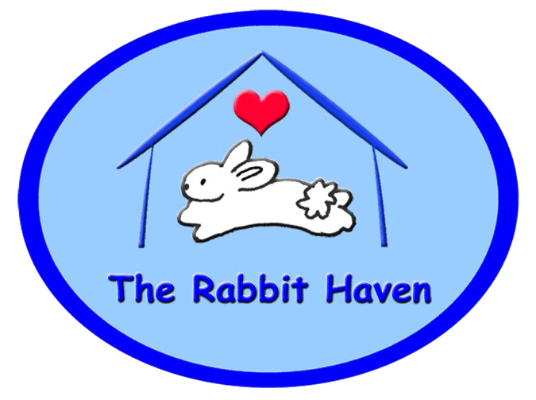
The Rabbit Haven Adoption Contract
PO Box 66594, Scotts Valley, CA 95067 (831) 600-7479 831 239-7119

Name:______________________________________ (ID required to adopt)
Address: Physical address/ mail (street address, city, state and zip code)
___________________________________________________________________________________
___________________________________________________________________________________
Telephone number(s) _______________ (H)_________________ (W)
E Mail(s): _________________________________________________
(Print) Name of rabbit(s) I am adopting: ________________________ __________________

I agree to the following facts, terms and conditions. Please read then initial each section of your contract.

- I agree to provide a safe, healthy, indoor environment for my rabbit. The rabbit will be set up in a place away from any predators, disease (raccoon droppings/fleas/mosquitoes) and exposure to adverse temperatures. I have adequate funds to be able to provide for the needs of this rabbit. I understand the costs of maintaining a healthy rabbit. This will include annual medical exams and any medical care the bunny may need later. ___

- I agree to have the rabbit as part of the family and not kept apart in a far off space or hutch. I understand the rabbit needs social interaction and love for their emotional well-being. I understand that ongoing contact is necessary to maintain the well being of my bunny. Long periods of isolation in closed rooms, garages etc. where the bunny cannot be a part of the family may create both emotional and physical harm. ______ Finally, all members of my family want the rabbit I am adopting. _____

- I understand that the enclosure size appropriate for the rabbit is a minimum of 4 X 4 or in a structure that is vertical in addition to run space. I understand that the bunny cannot stay in an enclosure all of the time and will require time and space to run about freely to get plenty of exercise. X pens may be used to provide a safe place that bunny can call home- other enclosures work well, such as NIC cubes. _____

- I understand that Rabbit Haven staff is available for free consultation to help with set up questions or with initial set up before or after my adoption. _______

- I agree to take my rabbit in for the first free exam within 7 days of my adoption and then annually thereafter. I agree to read the Rabbit Haven Rabbit Care information and agree to take the rabbit to a vet as needed. ___

- I agree if I am adopting a pair that I have read and understand the bonding needs of this pair. I have learned about housing issues and other matters needed for their safety while bonding occurs. I agree to be in touch with my counselor to continue bonding processes as needed. _____

- (If renting or leasing): I have the permission of my landlord to keep a rabbit or rabbits in my house or apartment. This permission is in writing in my lease. _____ If I move, I agree to secure housing that will allow the rabbit __________

- I agree to provide the rabbit with fresh food and water daily including hay, high fiber pellets and plenty of dark leafy greens. I agree to read and follow the dietary guidelines provided by Rabbit Haven ______

- If my rabbit is a baby I understand that I am responsible to have this rabbit spayed or neutered by 4 months for males or at 6 months for females. I understand that this will be my responsibility. I agree to contact The Rabbit Haven & to send a copy of the s/n certificate when my rabbit is s/n to the Rabbit Haven . _____

- Deposits. I am paying a deposit for the spay and neuter of my adopted rabbit. $55.00. 100% of this deposit will be returned when I have spayed or neutered the rabbit. Send your spay certificate to PO Box 66594 Scotts Valley ca 95067 for your full refund. ________________
- I agree not to sell, breed or to use this rabbit(s) for experimentation.- or for any reason.___________
- I understand that this is a companion pet rabbit adopted as an addition to my family . ____________

- I agree not to give this rabbit to a third party. (Including a shelter). This is a permanent adoption. ______

- I agree not to euthanize the rabbit except in the case of terminal illness & intractable pain with no hope of recovery, and in that case, the euthanasia must be performed by a licensed veterinarian. _____

- I have no allergies to rabbit fur or hay and no one in my household has an allergy to rabbit fur or food. ____

- I agree to handle the rabbit appropriately and carefully as instructed by The Rabbit Haven. ______ I agree not to add an additional pet that may be a danger to the rabbit. (for example: Certain dogs, snakes or any predatory animals) _______ I agree to read all of my education materials and to follow approved rabbit care guidelines as outlined in this material ___________

- I have no animals that will harm the rabbit _______. I will supervise play activities while introducing pets and will follow introduction guidelines given by TRH ___________

- (If there is a young child at home under 7) I agree to supervise all rabbit play with my children so the rabbit will not be harmed. _________

- I agree to make my home bunny safe. I will cover all cords the rabbit has access to so that the rabbit will not be injured. I have learned how to make my home bunny safe. ________

- I agree to take my rabbit to be examined by either my own rabbit vet or to one of the rabbit savvy vets I have rec. a referral to see by the Rabbit Haven.. This first exam with TRH referred Vet is free. In the future, I agree to provide my new rabbit companion with any needed medical care they may require. I agree not to euthanize my rabbit due to a medical need where money is the main factor in saving the rabbit’s life. Note: There are many helping agencies available to assist with one time high medical costs. _______

- I understand that my adoption is meant to be permanent. In emergencies, rehoming must be facilitated through The Rabbit Haven. I agree not to take the rabbit to any animal shelter or to another rescue. I understand that I may not give the rabbit to another party. I understand that rehoming program is available through TRH and that this process may take 2 to 16 weeks or longer to facilitate. Rehoming needs, due to death of owner, or other emergency reasons may be arranged more quickly with our Director, Director@therabbithaven.org or a delegate. _______

- I understand that there is a tax-deductible adoption donation for the adoption of my new rabbit. This donation is not refundable. _______

- I understand that if these conditions are not met, that TRH has the right to reclaim the rabbit. __________

______________________________________________ Printed name of adopter

______________________________________________ (adult) ____________________________ (date)
Adoptive Family Representative (signature)
______________________________________________ ____________________________ (date)
Rabbit Haven Representative (signature)

Referred to ______________________________________________ DVM (vet)
Adoption donation $ ____________________ check / cash _______
Deposit $ ____________________
Other product $ ____________________
Total $ ____________________
Entered ASM )_______

